**

**Journal of Cyber Security and Risk Auditing**

[https://www.jcsra.thestap.com/](https://www.jcsra.thestap.com/%20%20)



**Title of the manuscript (16 font size, Bold, Align left and Times New Roman)**

**Almaha Adel Almuqren 1**

*1 Department name, Name of University, City, Postal code, Country (The font size should be 10, the font type is Times New Roman and italic*)

**A R T I C L E I N F O**

**Article History**

**Received**

**Accepted**

**Published**

**Academic Editor:**

**Vol.2025, No.1**

**DOI:**

[Creative Commons License](https://creativecommons.org/licenses/by/4.0/)**A B S T R A C T**

- The font size should be 10.

- The font type is Times New Roman.

**Keywords:** Keyword 1; Keyword 2; Keyword 3; Keyword 4 and Keyword 5.

1. **Introduction (Heading 1)** font size 11, font type is Times New Roman.

- The font size should be 10.

- The font type is Times New Roman.

1. **Literature Review (Heading 2)** font size 11, font type is Times New Roman.

## *IoT Architecture (font size 11, font type is Times New Roman and italic)*

- The font size should be 10.

- The font type is Times New Roman.

- Figures must be numbering.

- Figures must be Bold.

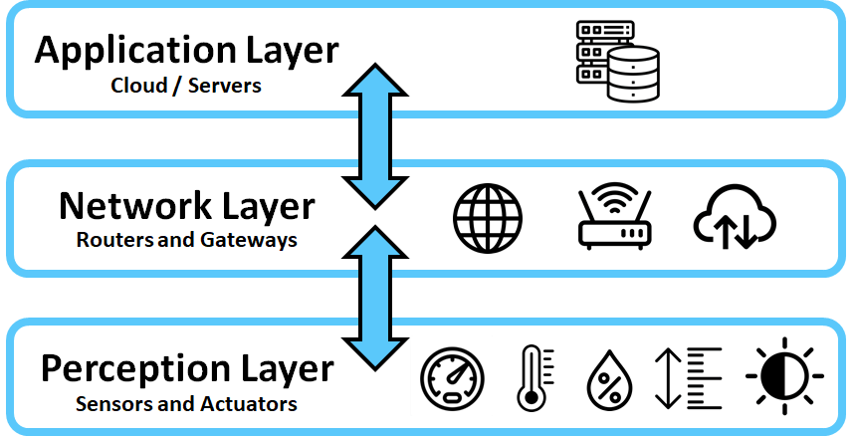

**Figure 1.** IoT architecture with 3-layers.

*(A) Application layer*

According to [11], application layer is responsible for delivering different services depending on the information stored on different servers for different applications such as smart health, smart cities, and smart homes.

*(B) Network layer*

, (1)

Where *i*, *j* is the pixel index, weight  determined by guided graph G, which is completely independent from the input image.

*2.2 Cyber Attacks on IoT*

*(A) Malicious Code Injection Attack*

The attacker attacks a node by physically infiltrating it with malicious code, which allows the attacker to seize control of the IoT network.

*(B) Phishing attack*

Sensitive information can be obtained by an attacker using an infected email or website to impersonate the user's confirming identity.

*(C) Spyware and Worms*

**3. Research Methodology**

In this study, to achieve the research objectives, we used a Systematic Literature Review (SLR) as shown in Figure 3.

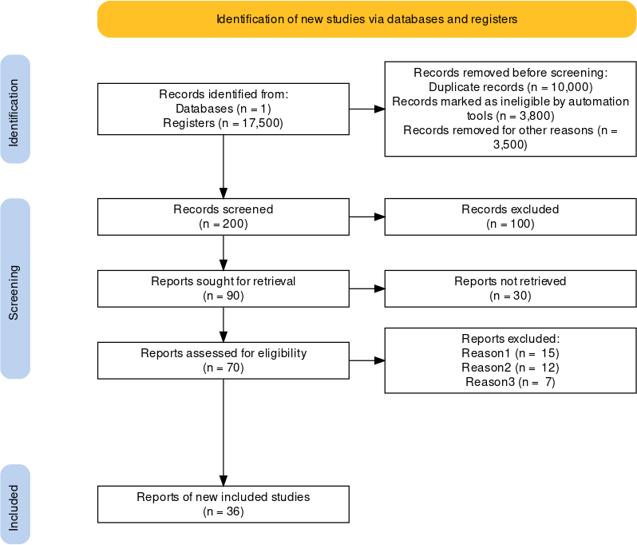

**Figure 3.** PRMISA methodology.

**4. Analysis and Findings**

As we mentioned in the preceding section, we analyzed the main threats in IoT based on three layers of IoT architecture including application layer, network layer and perception layer.

*4.1 Findings of Classification of Threats and Attacks in Application Layer*

Based on the analysis of the literature review, we categorized cyber threats and attacks in application layer of IoT into technical threats, as presented in Table 1.

- Tables must be numbering.

- Figures must be Bold.

**Table 1.** Classification of Threats and Attacks in Application Layer

|  |  |  |
| --- | --- | --- |
| **Layer** | **Type of threats and attacks** | **Description** |
| Application layer | Malicious Code Attacks [7],[6] | Attacks through running malicious codes. |
| Cross-Site Scripting Attack [8] | Attacker runs malicious codes on the web browser of the victim by adding malicious code on legitimate websites thus allowing him to tamper the application. |
| Botnet [9] | The hacker hijacks network of devices by Botnet and can control them from a single access point. |

**5. Conclusion**

- The font size should be 10.

- The font type is Times New Roman.

## Conflicts Of Interest

The author declares no conflicts of interest.

## Funding

No funding.

## Acknowledgment

This work was supported by Name of funding agency under Grant BS123456.

**Appendix**

Appendixes, if needed, appear before the acknowledgment.

**References (APA format) and should be cited as numbers [1] in the main text**

1. Yang, Y., Wu, L., Yin, G., Li, L., & Zhao, H. (2017). A survey on security and privacy issues in Internet-of-Things. *IEEE Internet of things Journal*, *4*(5), 1250-1258.
2. Rejeb, A., Rejeb, K., Treiblmaier, H., Appolloni, A., Alghamdi, S., Alhasawi, Y., & Iranmanesh, M. (2023). The Internet of Things (IoT) in healthcare: Taking stock and moving forward. *Internet of Things*, *22*, 100721.
3. Sengupta, J., Ruj, S., & Bit, S. D. (2020). A comprehensive survey on attacks, security issues and blockchain solutions for IoT and IIoT. *Journal of network and computer applications*, *149*, 102481.
4. Hassija, V., Chamola, V., Saxena, V., Jain, D., Goyal, P., & Sikdar, B. (2019). A survey on IoT security: application areas, security threats, and solution architectures. *IEEe Access*, *7*, 82721-82743.

**Biographies (**Required**)**



**Author A.** Description about the author A (in 5-6 lines). Email should be provided at the end. [mail@email.com](mailto:mail@email.com)

**（All authors must provide an email address.）**



**Author B.** Description about the author A (in 5-6 lines). Email should be provided at the end. [mail@email.com](mailto:mail@email.com)

**（All authors must provide an email address.）**